Krishna Bhandari

Git init-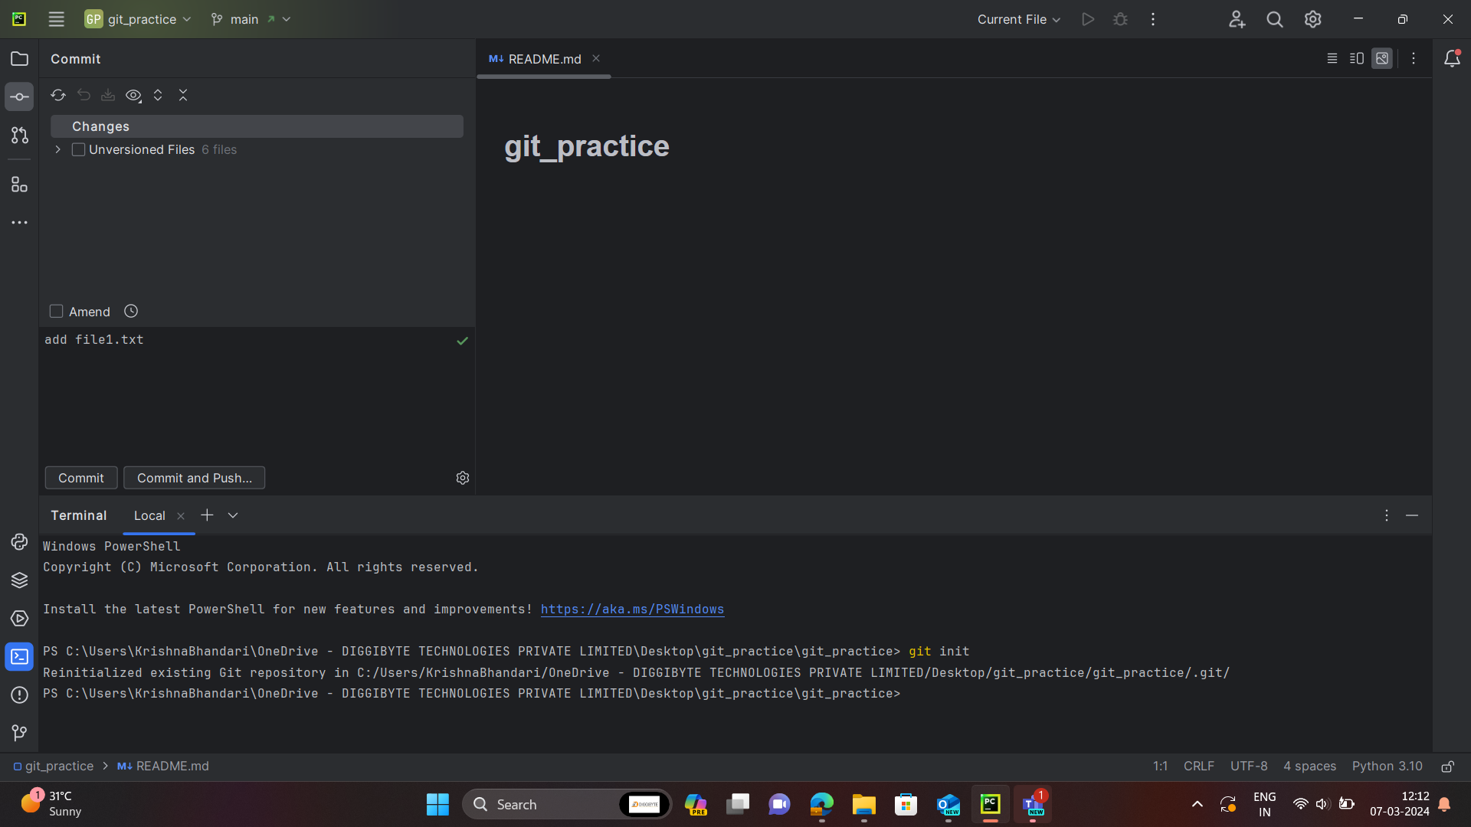

Git status

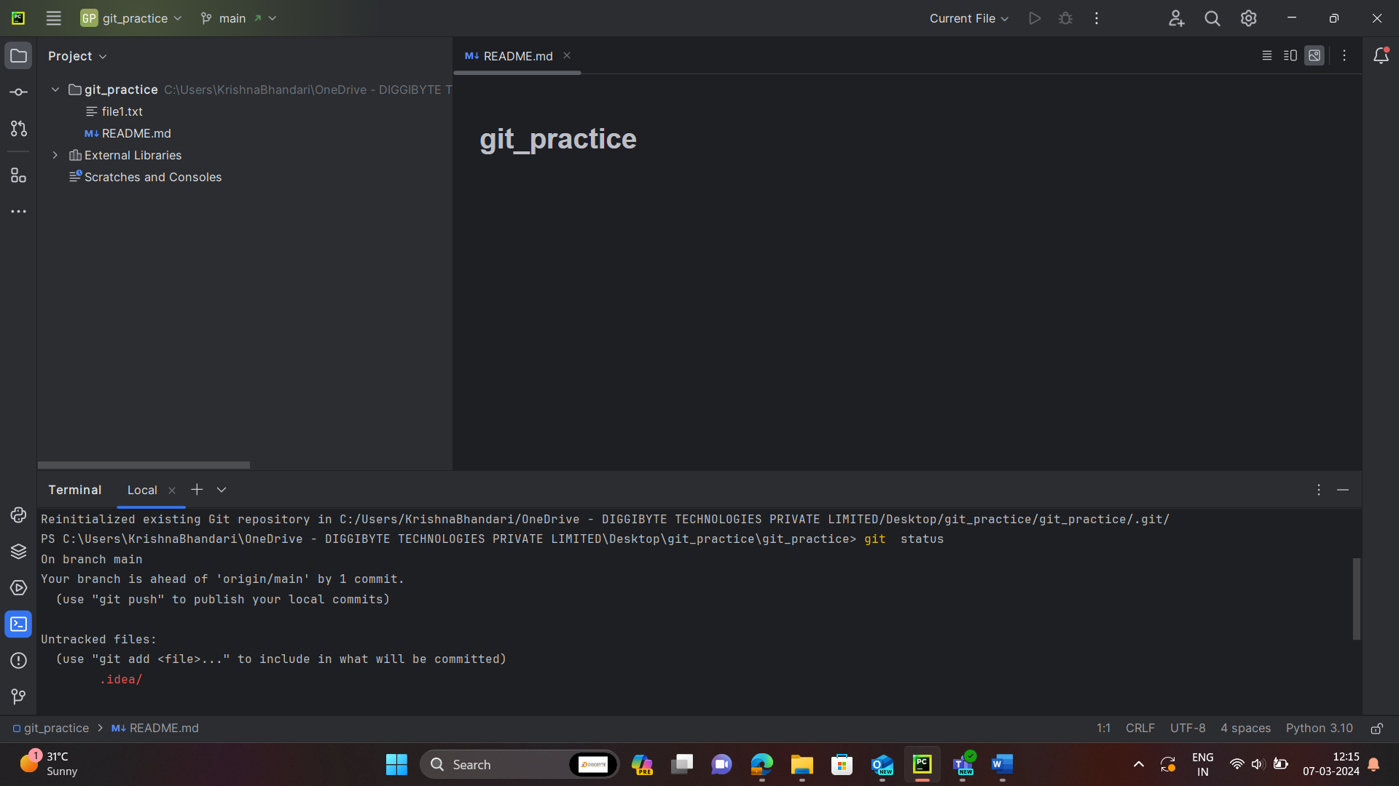

git config --get-all user.name

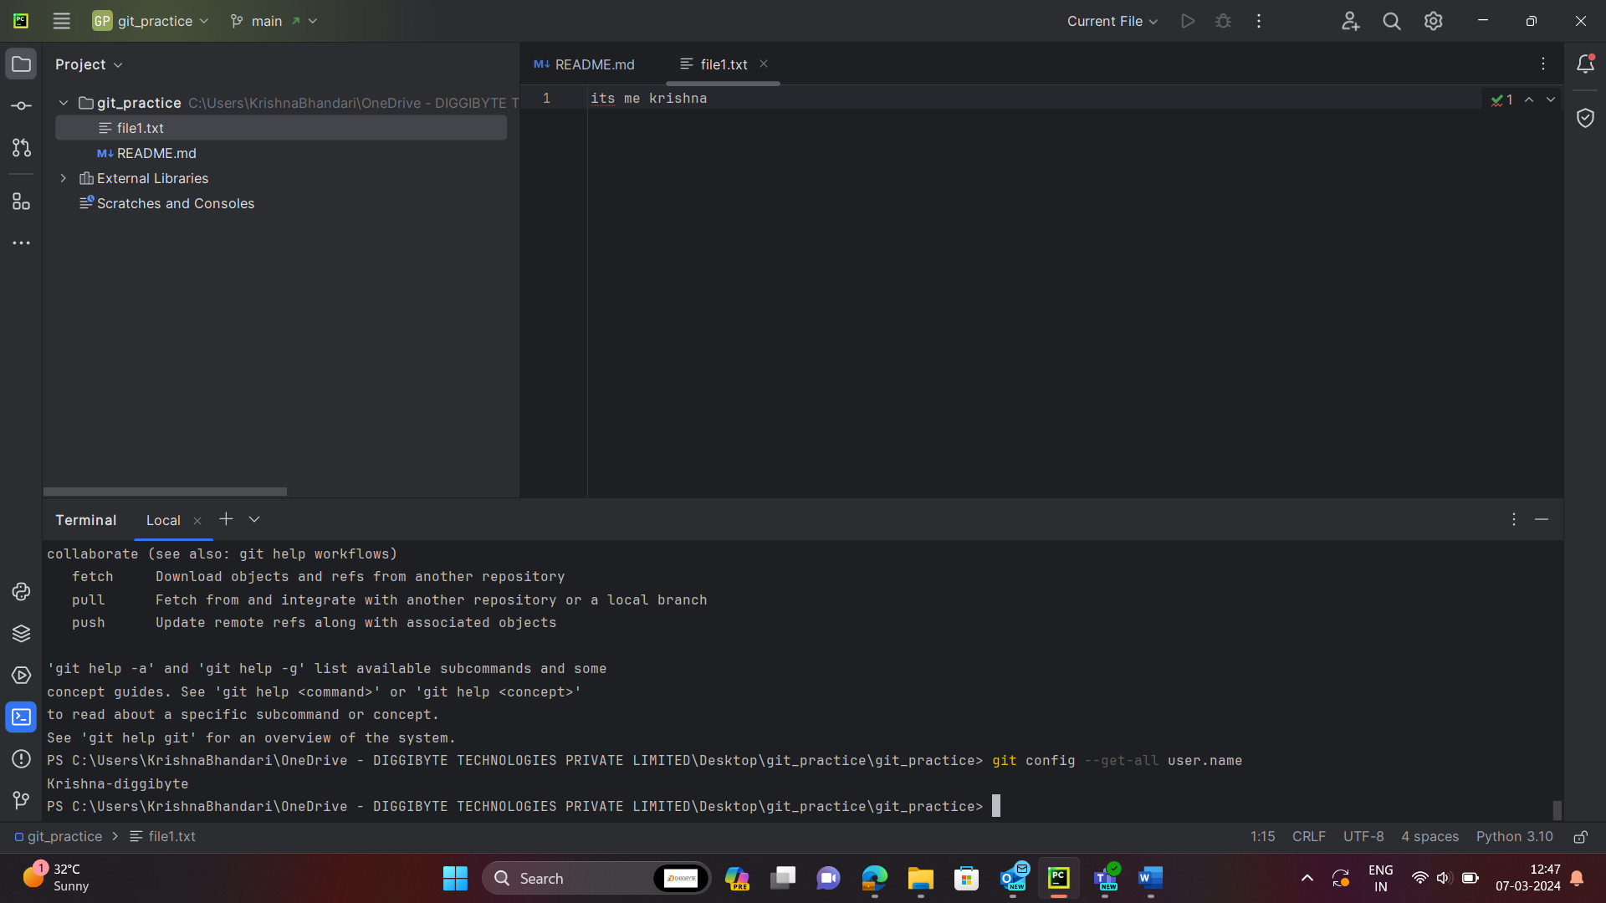

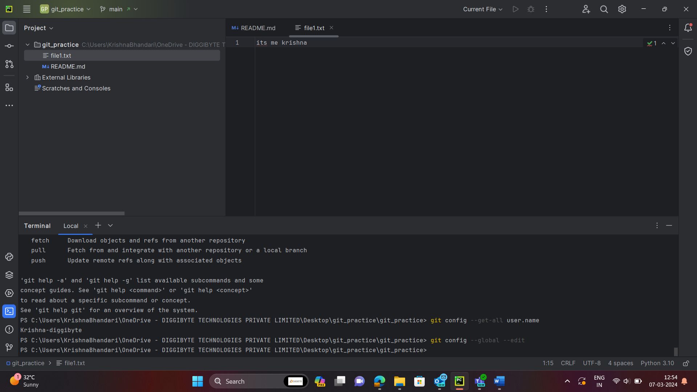

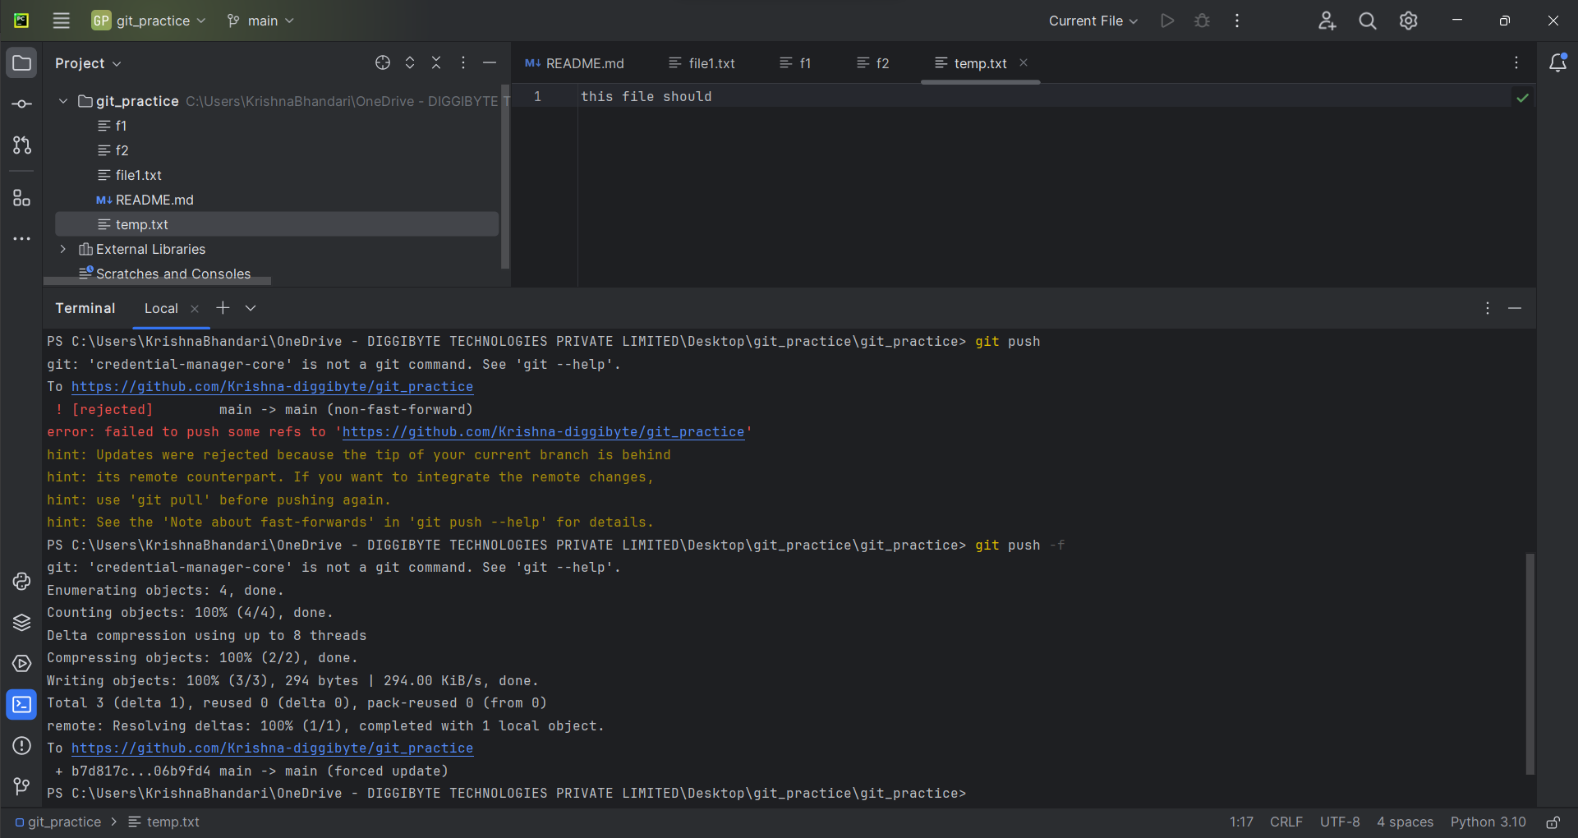 Git reset

Force push in github

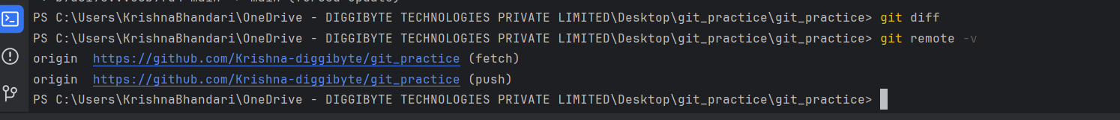remote -v

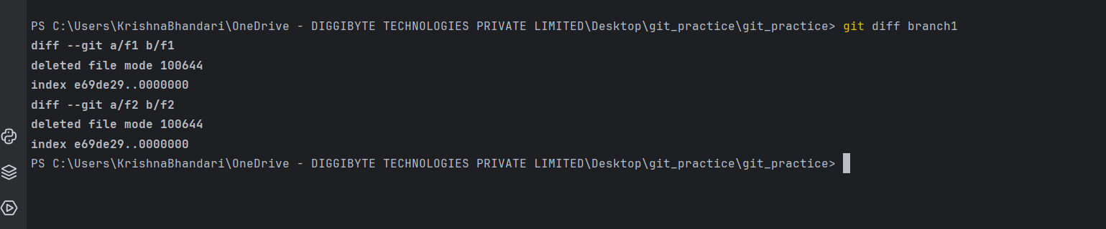git diff

fetch and pull

total commits

